附件3

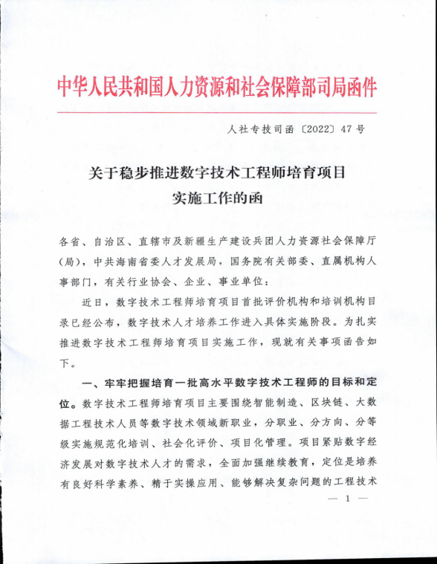

|  |
| --- |
|  |
|  | C:\Users\Lenovo\AppData\Local\Temp\ksohtml6288\wps13.png |

|  |
| --- |
|  |
|  | C:\Users\Lenovo\AppData\Local\Temp\ksohtml6288\wps14.png |

|  |
| --- |
|  |
|  | C:\Users\Lenovo\AppData\Local\Temp\ksohtml6288\wps15.png |

|  |
| --- |
|  |
|  | C:\Users\Lenovo\AppData\Local\Temp\ksohtml6288\wps16.png |

|  |
| --- |
|  |
|  | C:\Users\Lenovo\AppData\Local\Temp\ksohtml6288\wps17.png |

|  |
| --- |
|  |
|  | C:\Users\Lenovo\AppData\Local\Temp\ksohtml6288\wps18.png |